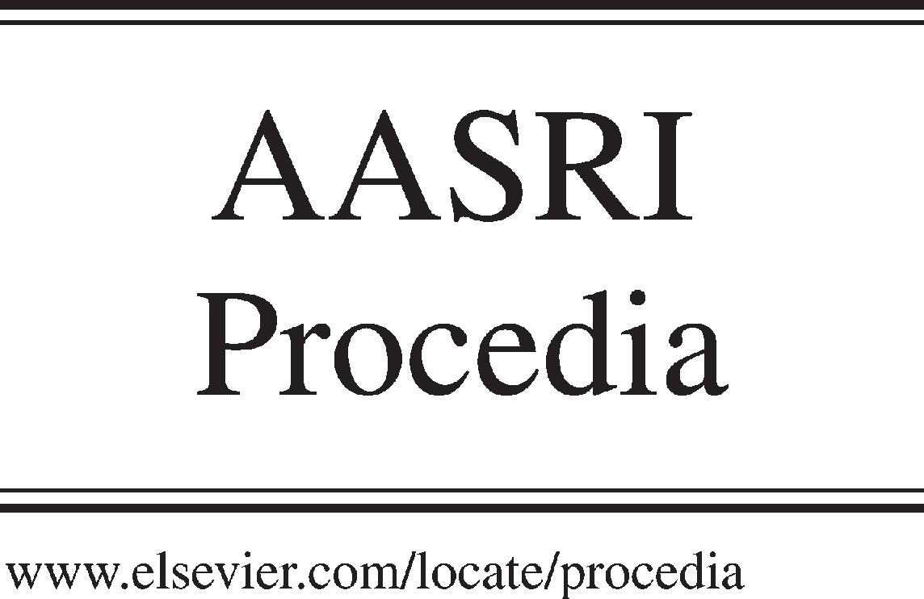Available online at [www.sciencedirect.com](http://www.sciencedirect.com/)



AASRI Procedia 3 (2012) 508 – 514

2012 AASRI Conference on Modeling, Identification and Control

Model Reference Adaptive Neural Sliding Mode control for Aero-engine

Jing Ma, Renhua Zhang *

*Northwestern Polytechnical University,127 Youyi Xilu,Xi’an Shaanxi 710072 China*

**Abstract**

The state parameter and work state of Aero-engine in the whole flight envelope are change greatly. So the controller should deal with parameter perturbation, disturbance and the change of external condition. In this paper the neural network sliding mode variable structure decoupling controller based on model reference adaptive for the aero-engine is designed. RBF neural network is used as the output of the sliding mode control, and sliding mode switching function is used as the neural network input. The weight of RBF network is adjusted adaptively by the error between reference model output and actual output. The results of simulation show that Model Reference Adaptive Neural Sliding Mode Controller (MRANBSMC) has a good control effect in the whole flight envelope. It eliminates the chattering phenomenon effectively and decouples well, which has a good robustness and control tracking performance in the disturbance and parameter perturbation.

© 2012 The Authors. Published by Elsevier B.V. Open access under [CC BY-NC-ND license.](http://creativecommons.org/licenses/by-nc-nd/3.0/)

© 2012 Published by Elsevier B.V. Selection and/or peer review [under responsi](http://creativecommons.org/licenses/by-nc-nd/3.0/)bility of American Applied Science Research Institute

Selection and/or peer review under responsibility of American Applied Science Research Institute

*Keywords :* aero-engine; Model Reference Adaptive; Sliding Mode variable structure; decoupling

# Introduction

In the actual project the controlled parameter is hoped to change along the certain desired track, which will made the system characteristics to be basically accordant to an ideal model and improve the control performance of the control system. Model reference adaptive control (MRAC) is the most extensive control

* Corresponding author. Tel.: +8613152037871; fax: +8602988495911.

*E-mail address:* [rabbymj@sina.com.](mailto:rabbymj@sina.com)

2212-6716 © 2012 The Authors. Published by Elsevier B.V. Open access under [CC BY-NC-ND license.](http://creativecommons.org/licenses/by-nc-nd/3.0/) Selection and/or peer review under responsibility of American Applied Science Research Institute doi:10.1016/j.aasri.2012.11.080

form of the follower and an effective way of control.

MRAC has the characteristics of clear performance and simple design method. The original adaptive model tracking control is designed either based on Lyapunov stability theory or the conception of hyper- stability to cope with the system parameter change or external disturbance. The two methods can ensure the error to be zero in finite time, but the common weakness of which is they can’t quantitative design the transient performance of error. To solve this problem, variable structure control has been highly thought of by its good transient performance and resistance to a wide range of parameters change ability. Since the 70s extensive research has been conducted on tracking model based with this method [1].

This paper proposes a combination of neural network and sliding mode control (SMC) is to control the aero-engine based on MRAC theory. SMC system includes reachable stage and sliding stage [2][3]. And only at sliding stage the system has robust to parameter perturbation and external interference. So the NN SMC scheme enable the system to be at sliding mode at began and keep it, and therefore eliminate the reachable stage. At the same time the NN can compensate the sliding mode switch control by introducing neuron control. When there is disturbance or parameter perturbation, the deviate state trajectory can automatic convergence to the sliding surface. The controller not only keeps the system to be robust under perturbation and external disturbance, but also to deceases or eliminates the chattering.

1. **Design of MRANBSMC**
   1. *Structure of controller*

The switching function is taken as the input of RBF NN and sliding mode variable structure controller is taken as the output of RBFNN [4][5]. The error between the output of reference model and real engine output is corrected by using the learning functions of neural network so that the aero-engine can track the reference model and turbofan decoupling control is obtained.

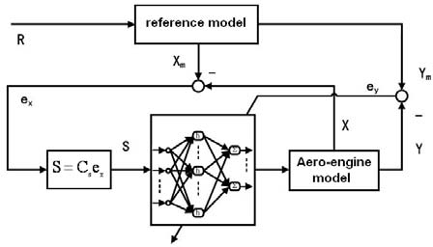

Fig.1.The block diagram of RBF sliding mode variable structure control based on model reference

* 1. *Description of math model*

Considering the following formulas of uncertain multivariable system:

*X p* (*t*)

 ( *Ap*

*Ap* (*t*)) *X p* (*t*)

(*Bp*

*Bp* (*t*))*U* (*t*)

*Dp f* (*t*)

*(1)*

where *X p* (*t*)  *Rn* ,*U * *Rm* , *f* (*t*)  *R*1 are the state vector, control vector and external disturbance, respectively.

*Ap * *Rn n* , *Bp * *Rn m* are the known nominal system matrix and the known nominal control matrix of the

controlled plant. *Ap Bp Dp* are the perturbed matrices and disturbance distribution matrices of *Ap Bp* .

The nominal equation can be written as

Choose the reference model as

*X p * *Ap X p*

 *BpU*

*(2)*

*Xm* (*t*)

*Am Xm* (*t*)

*Bm R*(*t*)

*(3)*

where

*X m* (*t*)

 *Rn* is the state variable of reference model,

*R*(*t*)

 *Rm* is uniformly bounded external input,

*Am * *Rnn* , *Bm * *Rnm* are the system and control matrices.

Suppose (3) satisfied *Am* , *Bm* , are Lebesgue measurable and bounded. ( *Am* , *Bm* ) is controllable matrix, and

*rank*(*Bm* )  *m* .

The aim of Model reference control is to make the state variable of controlled plant to track that of reference model. So the state variable of error system is defined

*e*(*t*)

*X m* (*t*)

*X p* (*t*)

*(4)*

Therefore the error model of model reference control system is written as

*e*(*t*)

*X m* (*t*)

*X p* (*t*)

 [ *Am X m* (*t*)

 *Bm R*(*t*)]

[( *Ap*

*Ap* (*t*)) *X p* (*t*)

 (*Bp*

*Bp* (*t*))*U* (*t*)

 *Dp f* (*t*)]

*(5)*

*Ame*(*t*)



 ( *Am*

 *Ap* ) *X p* (*t*)

 *Bm R*(*t*)

 *BpU* (*t*)

*Ap* (*t*) *X p* (*t*)

*Bp* (*t*)*U* (*t*)

 *Dp f* (*t*)

Then nominal model of error system has the following structure



*e*(*t*)

*Ame*(*t*)

 ( *Am*

 *Ap* ) *X p* (*t*)

 *Bm R*(*t*)

 *BpU* (*t*)

*(6)*

* 1. *Model completely following condition*

To achieve the completely tracking, that is

lim *e*(*t*)

*t *

 0 .There exists matrix *U* that satisfy (7) for any

state *X p* , external reference R and uncertain factors [6].

( *Am*

 *Ap* ) *X p* (*t*) 

*Bm R*(*t*)

 *BpU* (*t*)

*Ap* (*t*) *X p* (*t*)

*Bp* (*t*)*U* (*t*)

 *Dp f* (*t*)  0

*(7)*

According to linear algebra theory, the sufficient condition for controlled system completely following reference model can be written as

*rank*[*Bp Am*

 *Ap* ]

 *rankBp*

 *rank*[*Bp*

*Bm* ]

*(8)*

*rank*[*Bp*

*Ap* ]

 *rank*[*Bp*

*Bp* ]

 *rank*[*Bp D*]

 *rankBp*

*(9)*

where (8) is called model matching condition of model perfect tracking,(9) is called uncertain matching condition of model perfect tracking.



If *f* (*t*)

 ( *Am*

 *Ap* ) *X p* (*t*)

*Bm R*(*t*)

*BpU* (*t*)

*Ap* (*t*) *X p* (*t*)

*Bp* (*t*)*U* (*t*)

*Dp f* (*t*)

*(10)*

is taken as parameter perturbation and external interference item for error nominal system (6). Therefore perfect model tracking condition of model reference control system is the invariant condition of the variable structure control system.

* 1. *Structure of reference model*

In the variable structure sliding mode control system the design reference model should satisfy two conditions[6]:  reference model should reflect desired control performance index,  it should meet completely tracking model match condition (8).Double variable control system is studied, which will cause coupling effect. So the reference should be decoupling system. In this paper the proper reference model that confine with performance index, is gained through state feedback decoupling and pole assignment for the engine model.

A certain type of turbofan engine mathematical model is [7].

*X * *AX * *BU*

*(11)*

|  |  |  |  |  |  |  |  |  |  |  |  |  |
| --- | --- | --- | --- | --- | --- | --- | --- | --- | --- | --- | --- | --- |
|  | | | *Y CX* |  | | | | | | | | |
|  |  | *a*11 | *a*12 | *b*11 | *b*12 |  | 0 | 0 |  |
| , | *U* [*m* , *A* ]*T* | , | *Y* [*nL* , *T* * ]*T* | , *A* | *a*21 | *a*22 | *b*21 | *b*22 | , *B* | 0 | 0 | , |
|  |  |  |  |  | 0 | 0 | 0 | 0 |  | 1 | 0 |  |
|  |  |  |  |  | 0 | 0 | 0 | 0 |  | 0 | 1 |  |

where *X*

*nL* , *nH*

, *m f*

, *A*8 *T f* 8 4

1

*C*

*c*21

0

*c*22

0

*d* 21

0 .

*d* 21

The block of state feedback method is shown in fig.2.



u

v

F

B

*x*

x

C

y

-

A

G

Fig.2. The block diagram of state feedback method

*c Ad*1 *B*

1 ,

1. *c Ad*2 *B H*

2

*c*1 *A*(*d*1 1)

*c*2 *A*(*d*2 1)

*(12)*

*G * *E* 1 *H*

*V * *FU*

1. ** *E* 1

 *GX*

*(13)*

*(14)*

where

*c*1 , *c*2

are the first and second row of matrix *C* , *d*1 , *d* 2

are the smallest integer *l* of

*c*1 *Al B * 0 , *c*2 *Al B * 0 .

State space equation after decoupling can be written as

|  |  |  |
| --- | --- | --- |
| *X* ( *A BG*) *X* | *BFv* | *(15)* |
| *Y CX* |  |  |
| *A*' *A BG* |  | *(16)* |
| *B*' *BF* |  | *(17)* |

Because state feedback decoupling method is a kind of integral type decoupling method, the dynamic performance is poor. Additional state feedback is used again for pole assignment to gain satisfactory performance. Let

1. ** *A*'

*B*'*G*

*(18)*

Now the reference model can be described by

*X m*

1. ** *B*' *F*

 *Am X m * *Bm R*

*(19)*

*(20)*

*Ym * *Cm X m*

* 1. *Design of RBF sliding mode controller*

Model errors are defined as *ex*

*X m X* , *ey*

 *Ym Y* .Since *Cm*

 *C* ,then *ey*

 *Ym * *Y*

 *Cex* .Therefore, When

*ex * 0 , *ey*

 0 , the system can track the reference model perfectly. This is, as long as the state value in state

equation can track the state value in reference model, the output of system can achieve reference model tracking.

Based on sliding mode control theory, the sliding surface can be designed as

where Cs

 [K I2 ] .

*S * *Cs ex*

*(21)*

In this paper NN and sliding mode variable structure are combined to design the control law. NN can approximate the output of SMC, and the input of NN is the switching function. The output error

*E * *ey*

 *Ym * *Y*

is chosen as the value function. Compared with pure SMC the design of control law must

satisfy the matching condition. Using NN to approximate the control law and to compensate the disturbance and with the learning ability of NN to adjust the control output, we make the system better tracking reference model to get ideal control performance.

The input vector of RBF NN is **x**

*j*

 [*s*1 , *s*2 ]*T*

set the number of hidden layer neurons is four, the radial

basis vector is *H*

 [*h*1 *h*2

*h*3 *h*4 ]*T* . *h* is gaussian basis function.

*h j * exp( 2 )

2

**x** *q j*

2

*j*

*j * 1,2,3,4

*(22)*

where *q j*

 [*q j*1

*q j* 2

]*T* is the central vector of *j* th network node;

 [1 2 3

4 ]*T*

is the network base

width vector,

*j * 0 is the base width parameter of *j* th node.

Weight vector of NN is *W*

The output of RBFNN is *u*

[*W*1 *W*2 ]*T* , *Wi*

 [*u*1 , *u*2 ]*T* .

 [*wi*1

*wi* 2

*wi*3

*wi* 4 ]*T* , *i*

 1,2 .

The cost function is defined as

*ui * *Wi T H*

 *wi*1*h*1

 *wi* 2 *h*2

 *wi*3*h*3

 *wi* 4 *h*4 , *i*

 1,2

*(23)*

*E* 1 ( *y*

*i* 2 *mi*

*yi* )2

*(24)*

Using gradient method adjust the weights of NN by the following structure



Then weight can be corrected by

*wij* (*k *1)

 *wij* (*k* )

*wij*

 *wij* (*k* )

 *E* (*k* )

*ij*

*w i*

*ij*

*(25)*

*wij*

*ij wij*

*Ei* (*k*)

*Ei*

*ij*

*w*

*ij*

*ij* ( *ymi*

 *yi* ) *h j*

*(26)*

where *ij* is learning law, positive constant.

So the learning law of weight is

*wij* (*k *1) 

*wij* (*k*) *ij*

 ( *ymi*

 *yi* )  *h j*

*(27)*

# The simulation result and analysis

In order to control multiple point control model of each region in the whole flight envelope of certain turbofan, we design reference model for every aero-engine mathematical model at the nominal point in each region. So all control system for different point in each region can track their respective reference model.

The chosen three points are (0,0),(2,1.4),(17.3,1.82).In the simulation the initial state is *x*0

every region respectively is

 [0,0,0,0] , C *s* in

- 0.7330

0.8919

0.4285

0.3394

1 0 ,

0 1

- 3.4284

1.3642

1.2834

0.1464

1 0 , -1.3480

0 1 0.2568

2.2793 1 0

0.7386 0 1

Control Performance is verified by simulation in the whole flight envelope. The results are shown in fig.3.- fig.5.

2

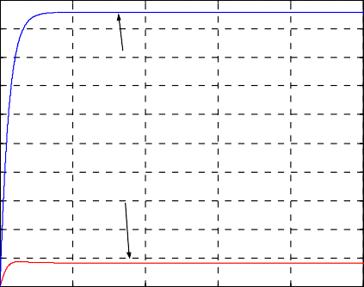

mf

A8

1.8

1.6

1.4

1.2

mf,A8

1

0.8

0.6

0.4

0.2

0

0 2 4 6 8 10

time(s)

1

0.9

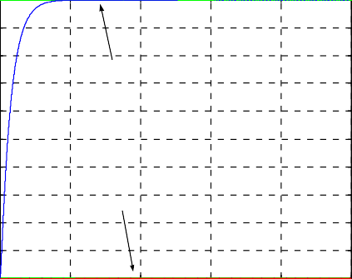

RnL,nL

RT4,T4

0.8

0.7

0.6

r,nL/T4

0.5

0.4

0.3

0.2

0.1

0

0 2 4 6 8 10

time(s)

Fig.3. *Rn*

 1 , *R* *  0 ,the curve of *m* , *A*8 , *nL* , *T* *

(H=0km,Ma=0)

*L T*4 *f* 4

1.6

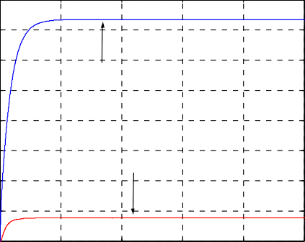

mf

A8

1.4

1.2

1

mf,A8

0.8

0.6

0.4

0.2

0

0 2 4 6 8 10

time(s)

1

0.9

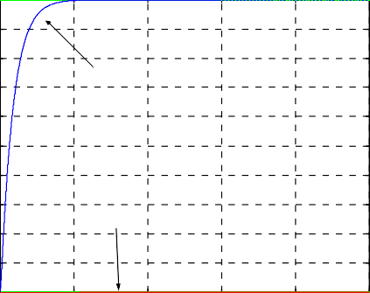

RnL,nL

RT4,T4

0.8

0.7

0.6

r,nL/T4

0.5

0.4

0.3

0.2

0.1

0

0 2 4 6 8 10

time(s)

Fig.4. *Rn * 1  *R* *  0 ,the curve of *m* , *A*8 , *nL* , *T* * (H=2km  Ma=1.4)

*L T*4 *f* 4

1.2

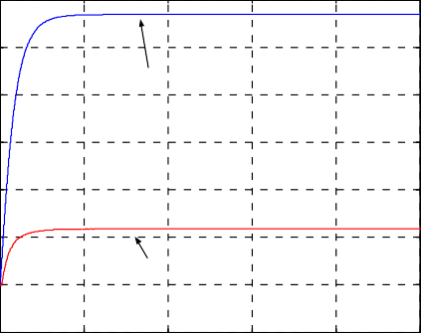

mf

A8

1

0.8

0.6

mf,A8

0.4

0.2

0

-0.2

0 2 4 6 8 10

time(s)

1

0.9

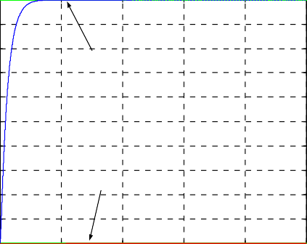

RnL.nL

RT4,T4

0.8

0.7

0.6

r,nL/T4

0.5

0.4

0.3

0.2

0.1

0

0 2 4 6 8 10

time(s)

Fig.5. *Rn * 1  *R* *  0 ,the curve of *m* , *A*8 , *nL* , *T* * (H=17.3km  Ma=1.82)

*L T*4 *f* 4

As is seen in fig.3, fig.4 and fig.5, when altitude and Mach number are (0,0),(2,1.4),(17.3,1.82) respectively, step response curve of control system has no overshoot. When input is [1,0],adjusting time is about 2s , When input is[0,1],adjusting time is about 1.2s,and the steady state error is zero. It is also shown that there is no chattering in the control of MRANBSMC.

# Conclusion

The Model Reference Adaptive Neural Sliding Mode Controller can decouple very well for the engine low-pressure rotor and turbine rear total temperature. And when disturbance and parameter perturbation exist, the response curve of control system does not obviously change. Nominal point and non nominal point of the same region in the whole envelope will get good results. This result proves that the control system has strong anti-jamming capacity, robustness and fairly good accuracy in its static and dynamic control. The controller enhances robustness of the control system, avoids the chattering in sliding-mode control, and improves the tracking converge.

# References

1. K.K.D. Yong, Asymptotic stability of model reference systems with variable structure control, IEEE Trans. Auto. Contr.,Vol. AC-22,No.2.Apr 1977,Page(s):279-281.
2. K.K.D. Yong, Design of variable structure model-following control systems, IEEE Trans. Auto. Contr.,Vol.AC-23, No.6,Dec 1978,Page(s):l079-1085.
3. Yao qionghui, huang jiqi, wu hansong, Vaiable structure control system, Chongqing university press,1997.7
4. Shiuh-Jer Huang, Kuo-Ching Chiou  An adaptive neural sliding mode controller for MIMO systems, Intell. Robot Syst.(2006)46 ,Page(s):285-301.
5. Nasser Sadati, Rasoul Ghadami, Mahdi Bagherpour, An adaptive neural network sliding mode controller

for robotic manipulators, IEEE Proceedings Control Theory and Applications, 2009.3,Page(s):1246-1251

1. Yao Xiangyu, Research on the application of Variable Structure Terminal Sliding Mode Control on aero- engine, Master’s dissertation,xi’an: Northwestern Polytechnical, 2004.3
2. Fan Siqi, aero-engine control, the northwest industry university press, 2008.6